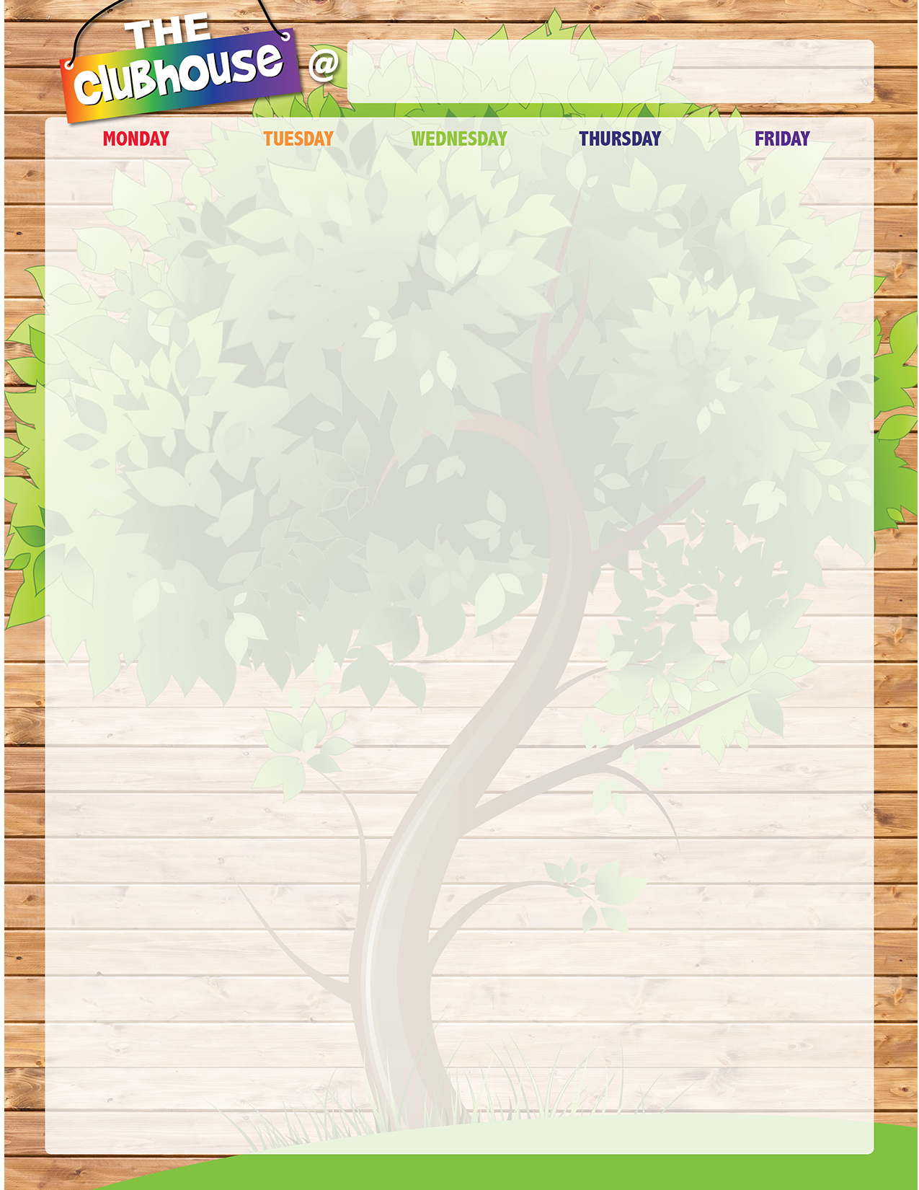
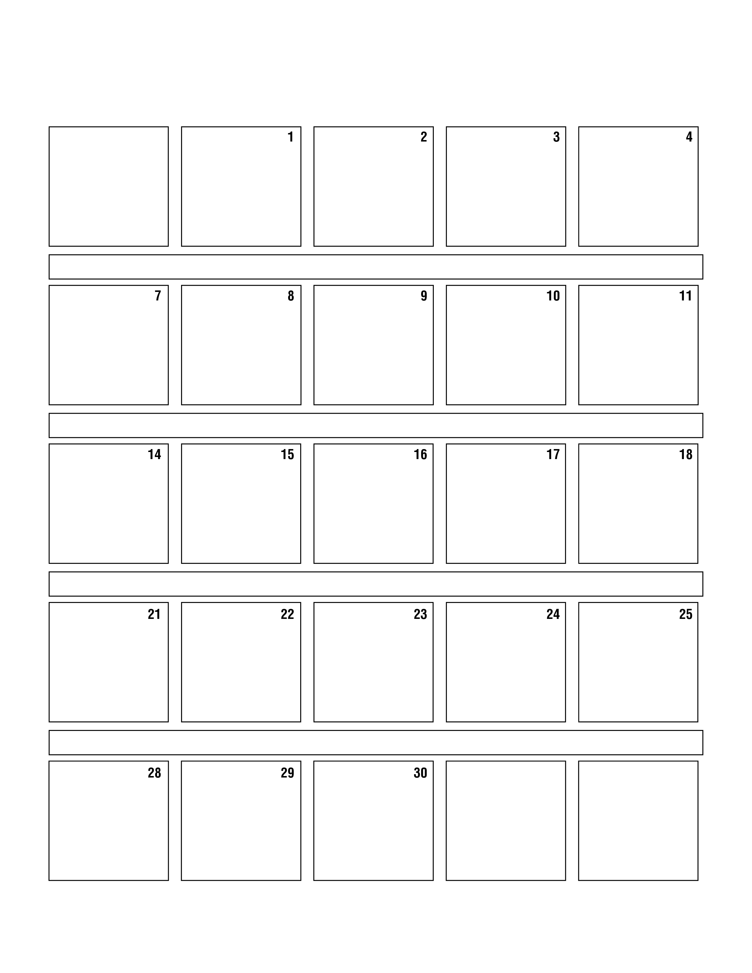
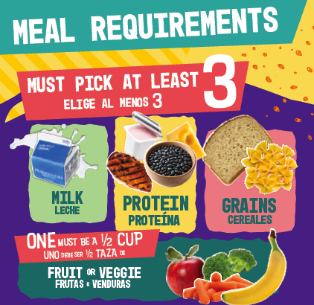
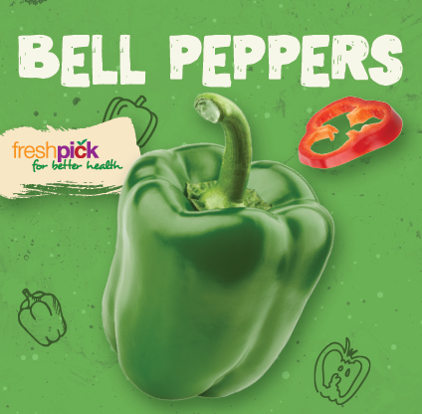
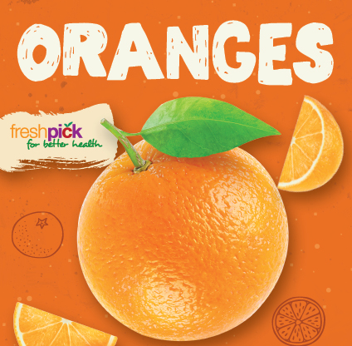


North Olmsted Elementary School

A. BBQ Chicken Nachos B. EZ Pizza Box
C. Peppi Salad w/ Flatbread D. Fun on the Run
E. PBJ Uncrustable w/ Cheese Stickand Pretzel Goldfish Aztec Corn Assorted Fruit Milk

A. Popcorn Chicken w/ Orange Sauce w/ Yakisoba Noodles B. EZ Pizza Box
C. Crispy Chicken Salad w/ Flatbread D. Fun on the Run
E. PBJ Uncrustable w/ Cheese Stick and Pretzel Goldfish Steamed Broccoli Assorted Fruit Milk
A. French Toast Sticks w/ Yogurt and Cheese Stick
B. EZ Hummus Box
C. Turkey Ham & Cheese Sub D. Fun on the Run
E. PBJ Uncrustable w/ Cheese Stickand Pretzel Goldfish Baked Tater Tots Assorted Fruit Milk

A. Mini Maple Pancakes w/ Turkey Sausage
B. EZ Hummus Box C. Crispy Chicken Wrap
D. Fun on the Run
E. PBJ Uncrustable w/ Cheese Stick and Pretzel Goldfish Smile Fries Assorted Fruit Milk

A. Penne w/ Beef Meatballs w/ Roll B. Strawberry Fields Parfait C. Peppi Salad w/ Flatbread D. Fun on the Run
E. PBJ Uncrustable w/ Cheese Stickand Pretzel Goldfish Steamed Green Beans Assorted Fruit Milk

A. Breaded Chicken Patty on Bun B. Strawberry Fields Parfait
C. Crispy Chicken Salad w/ Flatbread D. Fun on the Run
E. PBJ Uncrustable w/ Cheese Stick and Pretzel Goldfish Steamed Carrots Assorted Fruit Milk

A. Big Daddy Cheese Pizza B. Yogurt Bagel Box
C. Turkey Ham & Cheese Sub D. Fun on the Run
E. PBJ Uncrustable w/ Cheese Stick and Pretzel Goldfish Steamed Mixed Vegetables Assorted Fruit Milk

A. Big Daddy Cheese Pizza B. Yogurt Bagel Box
C. Crispy Chicken Wrap D. Fun on the Run
E. PBJ Uncrustable w/ Cheese Stick and Pretzel Goldfish Steamed Green Beans Assorted Fruit Milk

A. Breaded Chicken Tenders & Dutch Waffle
B. EZ Breakfast Box C. Turkey & Cheese Sub
D. Fun on the Run
E. PBJ Uncrustable w/ Cheese Stick and Pretzel Goldfish Sweet Potato Fries Assorted Fruit Milk

A. Mini Chicken Corn Dogs B. EZ Breakfast Box C. American Sub D. Fun on the Run
E. PBJ Uncrustable w/ Cheese Stick and Pretzel Goldfish Baked Tater Tots Assorted Fruit Mik

A. Beef & Cheese Nachos B. EZ Pizza Box
C. Chef Salad w/ Flatbread D. Fun on the Run
E. PBJ Uncrustable w/ Cheese Stick and Pretzel Goldfish Seasoned Black Beans Assorted Fruit Milk

A. Bosco Cheesy Breadsticks w/ Marinara Dipping Cup B. EZ Pizza Box
C. Taco Salad w/ Tortilla Chips D. Fun on the Run
E. PBJ Uncrustable w/ Cheese Stick and Pretzel Goldfish Steamed Green Beans Assorted Fruit Milk

A. Breaded Chicken Drumstick w/ Biscuit
B. EZ Hummus Box C. Turkey & Cheese Sub
D. Fun on the Run
E. PBJ Uncrustable w/ Cheese Stick and Pretzel Goldfish Mashed Potatoes w/ Gravy Assorted Fruit Milk

A. General Tso Chicken w/ Brown Rice
B. EZ Hummus Box C. American Sub D. Fun on Run
E. PBJ Uncrustable w/ Cheese Stick and Pretzel Goldfish Steamed Broccoli & Carrots Assorted Fruit Milk

A. Chicken Nuggets w/ Roll B. Strawberry Fields Parfait C. Chef Salad w/ Flatbread D. Fun on the Run
E. PBJ Uncrustable w/ Cheese Stick and Pretzel Goldfish Steamed Green Beans Assorted Fruit Milk

A. Beef Hot Dog on Bun B. Strawberry Fields Parfait
C. Taco Salad w/ Tortilla Chips D. Fun on the Run
E. PBJ Uncrustable w/ Cheese Stick and Pretzel Goldfish Vegetarian Baked Beans Assorted Fruit Milk

A. Big Daddy Cheese Pizza B. Yogurt Bagel Box
C. Turkey & Cheese Sub D. Fun on the Run
E. PBJ Uncrustable w/ Cheese Stick and Pretzel Goldfish Steamed Broccoli Assorted Fruit Milk

A. Big Daddy Cheese Pizza B. Yogurt Bagel Box C. American Sub D. Fun on the Run
E. PBJ Uncrustable w/ Cheese Stick and Pretzel Goldfish Steamed Corn Assorted Fruit Milk

A. Walking Nachos Beef & Cheese B. EZ Breakfast Box
C. Crispy Chicken Wrap D. Fun on the Run
E. PBJ Uncrustable w/ Cheese Stickand Pretzel Goldfish Aztec Corn Assorted Fruit Milk
A. Breaded Chicken Tenders w/ Bug Bites Grahams B. EZ Pizza Box
C. Pretzel Chicken Salad w/ Flatbread D. Fun on the Run
E. PBJ Uncrustable w/ Cheese Stick and Pretzel Goldfish Steamed Green Beans Assorted Fruit Milk

A. Chicken Nuggets w/ Dinner Roll B. EZ Hummus Box
C. Crispy Chicken Wrap D. Fun on the Run
E. PBJ Uncrustable w/ Cheese Stick and Pretzel Goldfish Steamed Broccoli Assorted Fruit Milk

