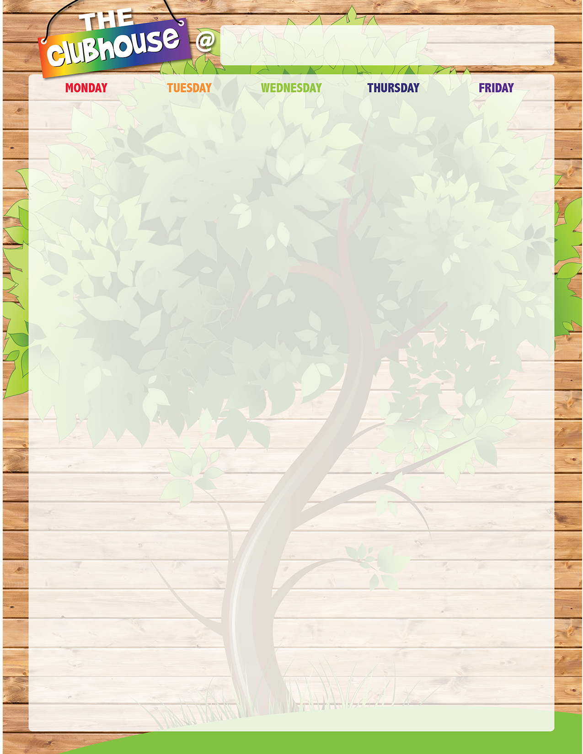


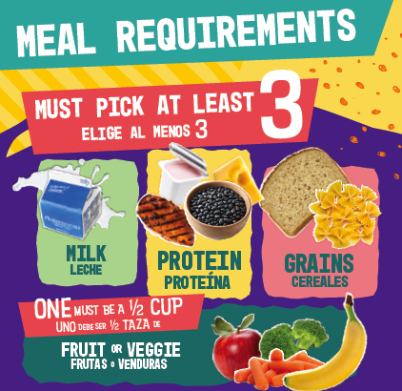





North Olmsted Elementary School

Nutrislice

See the link

on the district's

Food Services homepage

for nutritional information.

Welcome Back!
A. Beef Hot Dog on Bun B. Strawberry Fields Parfait
All C. Taco Salad w/ Tortilla Chips First D. Fun on the Run
Meals E. PBJ Uncrustable w/ Cheese Stick Are and Pretzel Goldfish
Free! Vegetarian Baked Beans Assorted Fruit
Milk

A. Big Daddy Cheese Pizza B. Yogurt Bagel Box C. American Sub D. Fun on the Run
E. PBJ Uncrustable w/ Cheese Stick and Pretzel Goldfish Steamed Corn Assorted Fruit Milk

A. Walking Nachos Beef & Cheese B. EZ Breakfast Box
C. Crispy Chicken Wrap D. Fun on the Run
E. PBJ Uncrustable w/ Cheese Stick and Pretzel Goldfish Seasoned Black Beans Assorted Fruit Milk
A. Chicken Tenders w/ Bug Bites Grahams
B. EZ Pizza Box
C. Pretzel Chicken Salad w/ Flatbread D. Fun on the Run
E. PBJ Uncrustable w/ Cheese Stick and Pretzel Goldfish Steamed Green Beans Assorted Fruit Milk

A. Chicken Nuggets w/ Dinner Roll B. EZ Hummus Box
C. Crispy Chicken Wrap D. Fun on the Run
E. PBJ Uncrustable w/ Cheese Stick and Pretzel Goldfish Steamed Broccoli Assorted Fruit Milk

A. Mini Pancakes w/ Yogurt and Cheese Stick
B. Strawberry Fields Parfait
C. Pretzel Chicken Salad w/ Flatbread D. Fun on the Run
E. PBJ Uncrustable w/ Cheese Stick and Pretzel Goldfish Baked Tater Tots Assorted Fruit Milk

A. Big Daddy Cheese Pizza B. Yogurt Bagel Box
C. Crispy Chicken Wrap D. Fun on the Run
E. PBJ Uncrustable w/ Cheese Stick and Pretzel Goldfish Steamed Carrots Assorted Fruit Milk

A. Bosco Cheesy Breadsticks w/ Marinara Dipping Cup B. EZ Breakfast Box
C. Turkey Ham & Cheese Sub D. Fun on the Run
E. PBJ Uncrustable w/ Cheese Stick and Pretzel Goldfish Steamed Broccoli Assorted Fruit Milk

