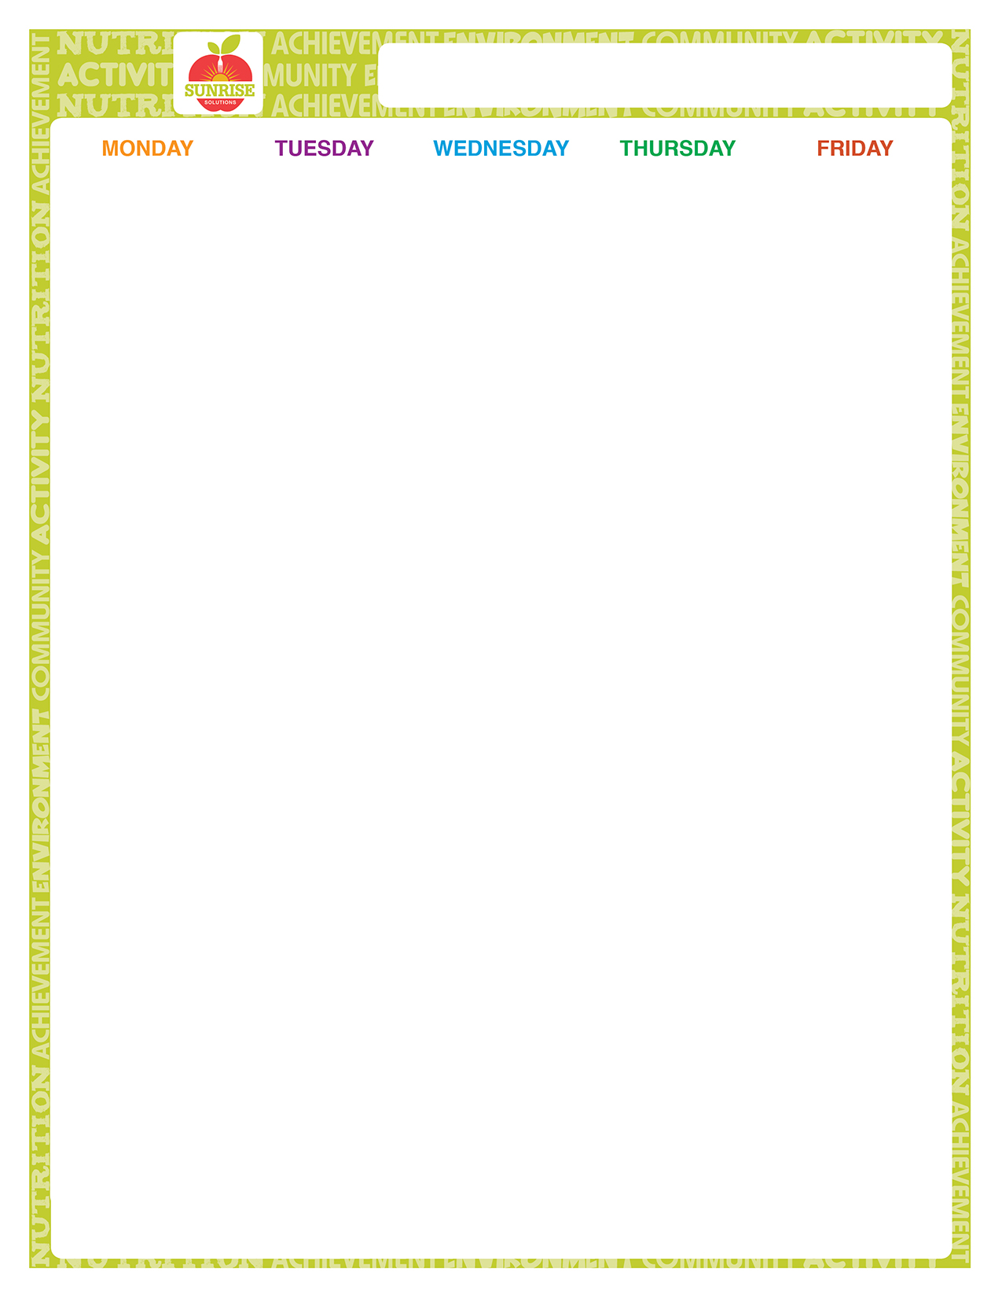
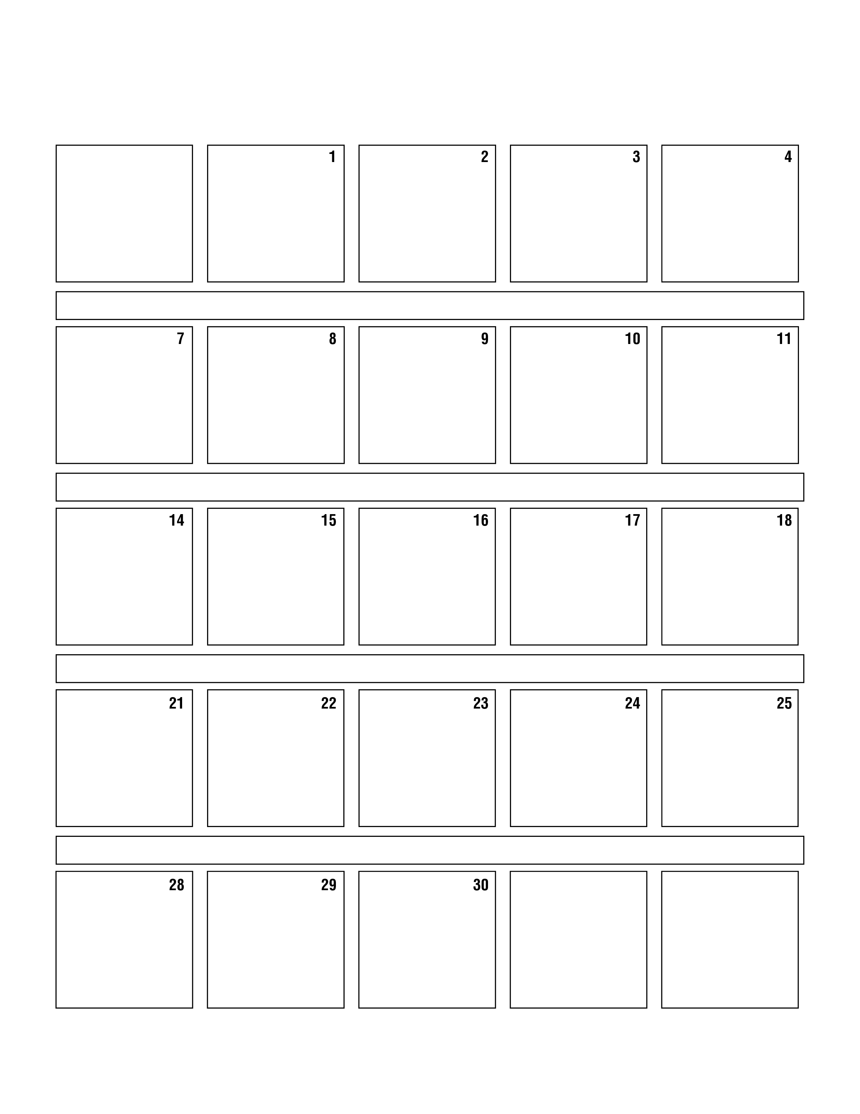
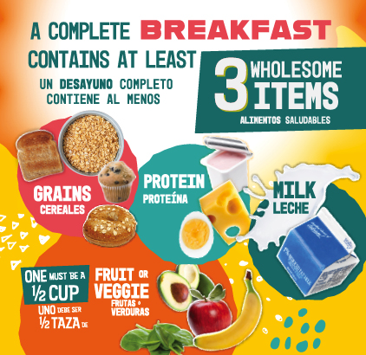
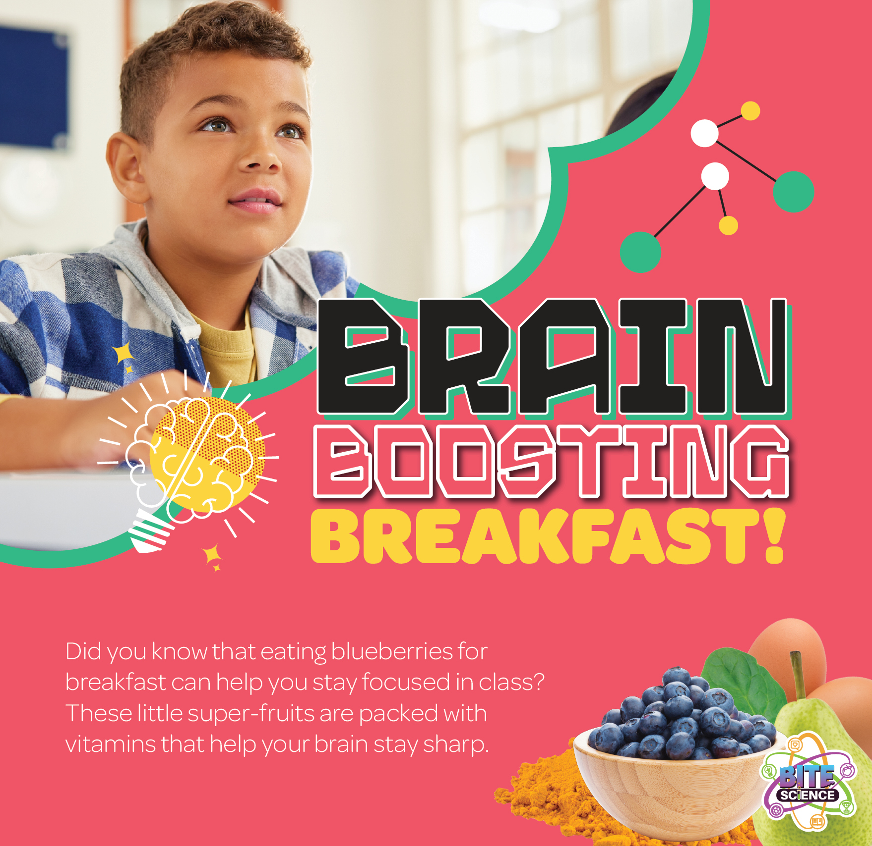


North Olmsted Elementary Breakfast

Choice of:
Mini Confetti Pancakes Cereal Cup w/ Graham Assorted Fruit or Juice Milk

Choice of:
Mini Berry French Toast Cereal Cup w/ Graham Assorted Fruit or Juice Milk

Choice of: Mini Cinnis
Cereal Cup w/ Graham Assorted Fruit Milk

Choice of: Snackin'Waffle-Maple Cereal Cup w/ Graham Assorted Fruit Milk

Choice of:
Pull-Apart Donut Holes Cereal Cup w/ Graham Assorted Fruit or Juice Milk

Choice of: Strawberry Stuffed Cream
Cheese Bagel Cereal Cup w/ Graham Assorted Fruit or Juice
Milk
Choice of: Cinnamon Stuffed Cream
Cheese Bagel Cereal Cup w/ Graham
Assorted Fruit Milk

Choice of: Blueberry Breakfast Bread
Cereal Cup w/ Graham Assorted Fruit Milk

Choice of: Cinnamon Bun
Cereal Cup w/ Graham Assorted Fruit Milk

Choice of: Cherry Frudel
Cereal Cup w/ Graham Assorted Fruit Milk

Choice of:
Chocolate Muffin w/ Cheese Stick Cereal Cup w/ Graham Assorted Fruit Milk

Choice of:
Mini Confetti Pancakes Cereal Cup w/ Graham Assorted Fruit or Juice Milk

Choice of:
Mini Berry French Toast Cereal Cup w/ Graham Assorted Fruit or Juice Milk

Choice of:
Mini Maple Pancakes Cereal Cup w/ Graham Assorted Fruit or Juice Milk

Choice of: Banana Breakfast Bread
Cereal Cup w/ Graham Assorted Fruit Milk

Choice of: Snackin'Waffle-Blueberry Cereal Cup w/ Graham Assorted Fruit Milk

Choice of: Mini Cinnis
Cereal Cup w/ Graham Assorted Fruit Milk

Choice of:
Pull-Apart Donut Holes Cereal Cup w/ Graham Assorted Fruit or Juice Milk

Choice of: Cinnamon Stuffed Cream
Cheese Bagel Cereal Cup w/ Graham Assorted Fruit or Juice
Milk

All First Meals Are Free!
Choice of: Cinnamon Stuffed Cream
Cheese Bagel Cereal Cup w/ Graham
Assorted Fruit Milk

Choice of: Banana Breakfast Bread
Cereal Cup w/ Graham Assorted Fruit Milk

