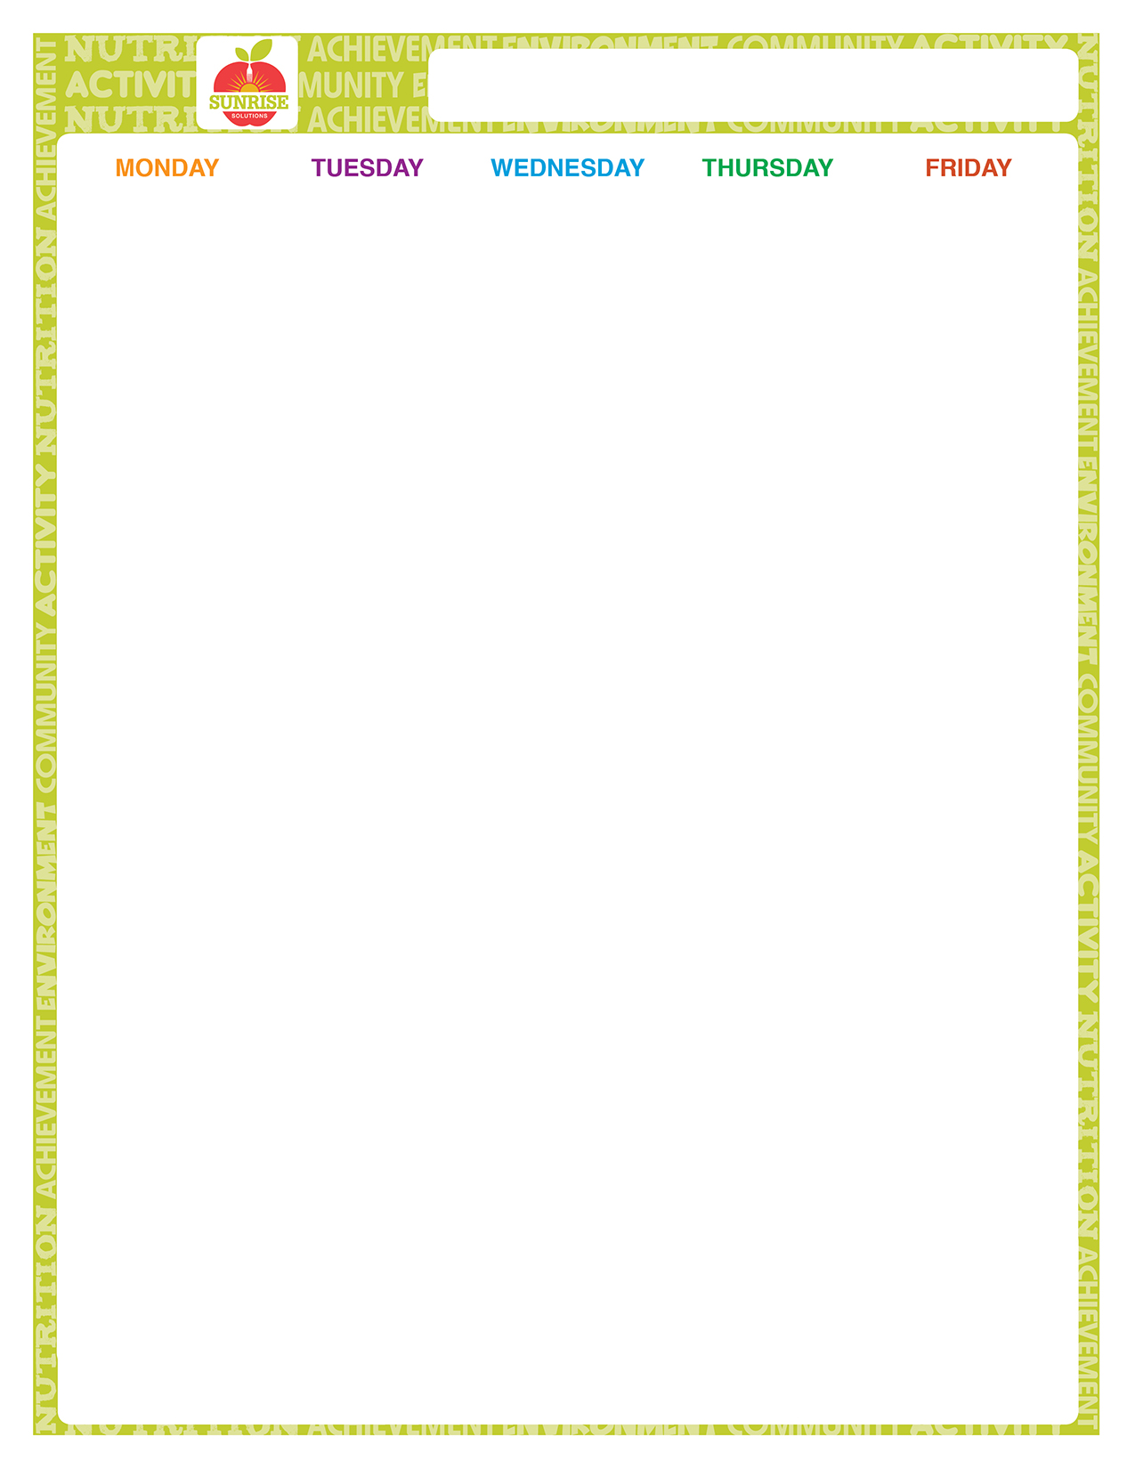




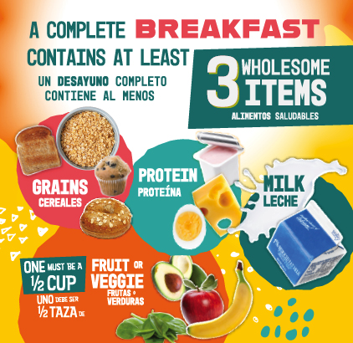
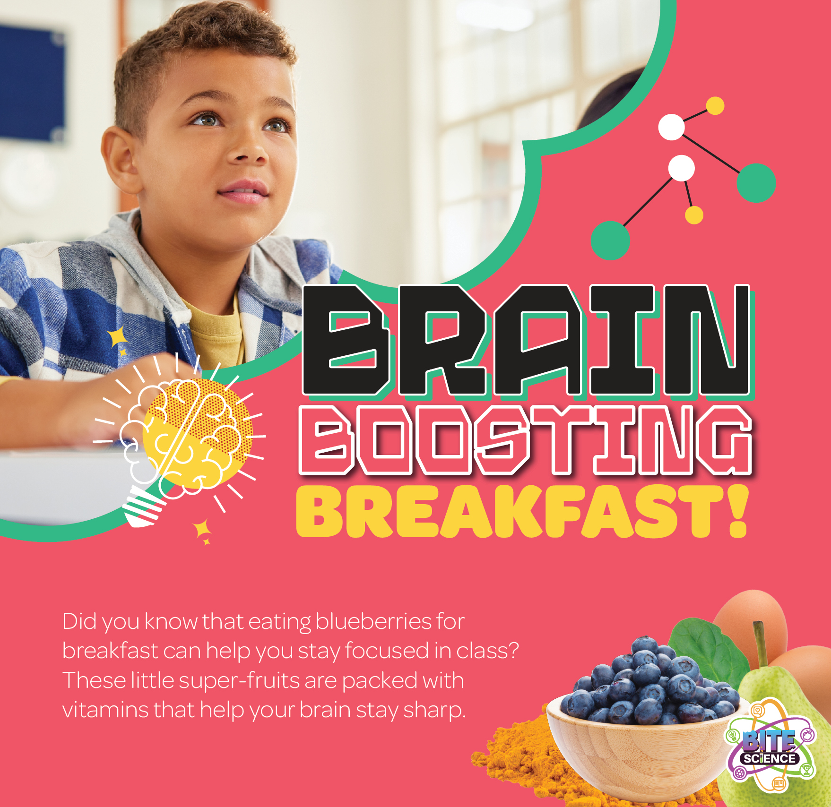

North Olmsted Elementary Breakfast

Welcome Back!

All Choice of:
First Ultimate Breakfast Round Meals Cereal Cup w/ Graham
Are Assorted Fruit or Juice Free! Milk
Choice of: Strawberry Stuffed Cream
Cheese Bagel Cereal Cup w/ Graham
Assorted Fruit Milk

Choice of: Apple Frudel
Cereal Cup w/ Graham Assorted Fruit Milk

Choice of:
Mini Berry French Toast Cereal Cup w/ Graham Assorted Fruit or Juice Milk

Choice of: Snackin'Waffle-Maple Cereal Cup w/ Graham Assorted Fruit Milk
Choice of: Strawberry Stuffed Cream
Cheese Bagel Cereal Cup w/ Graham Assorted Fruit or Juice
Milk

Choice of: Blueberry Breakfast Bread
Cereal Cup w/ Graham Assorted Fruit Milk

Choice of: Cinnamon Bun
Cereal Cup w/ Graham Assorted Fruit Milk

