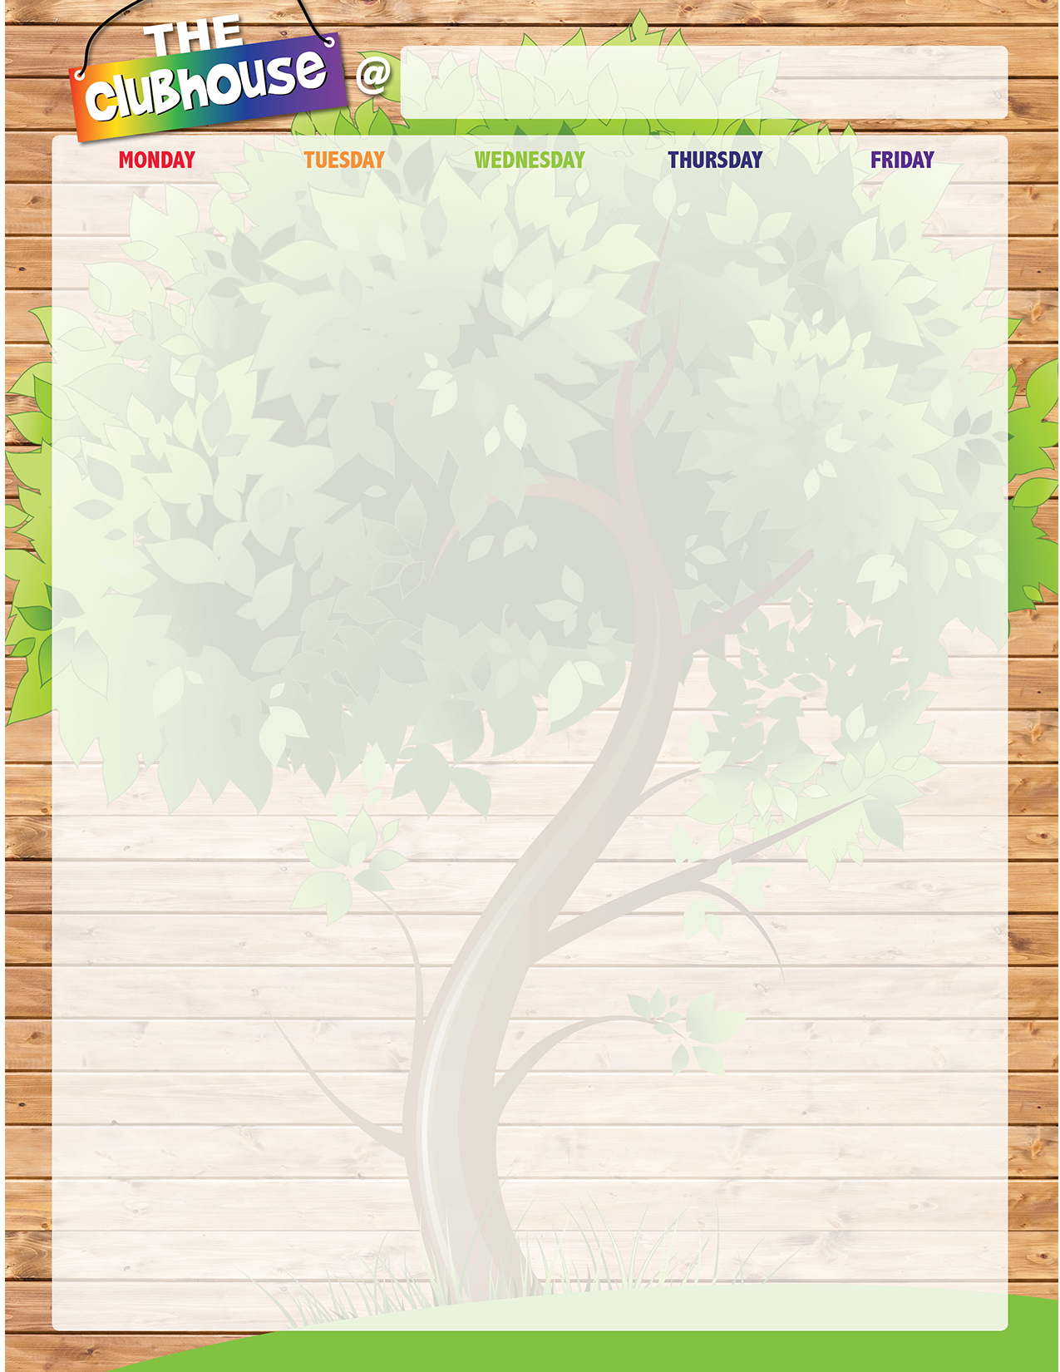
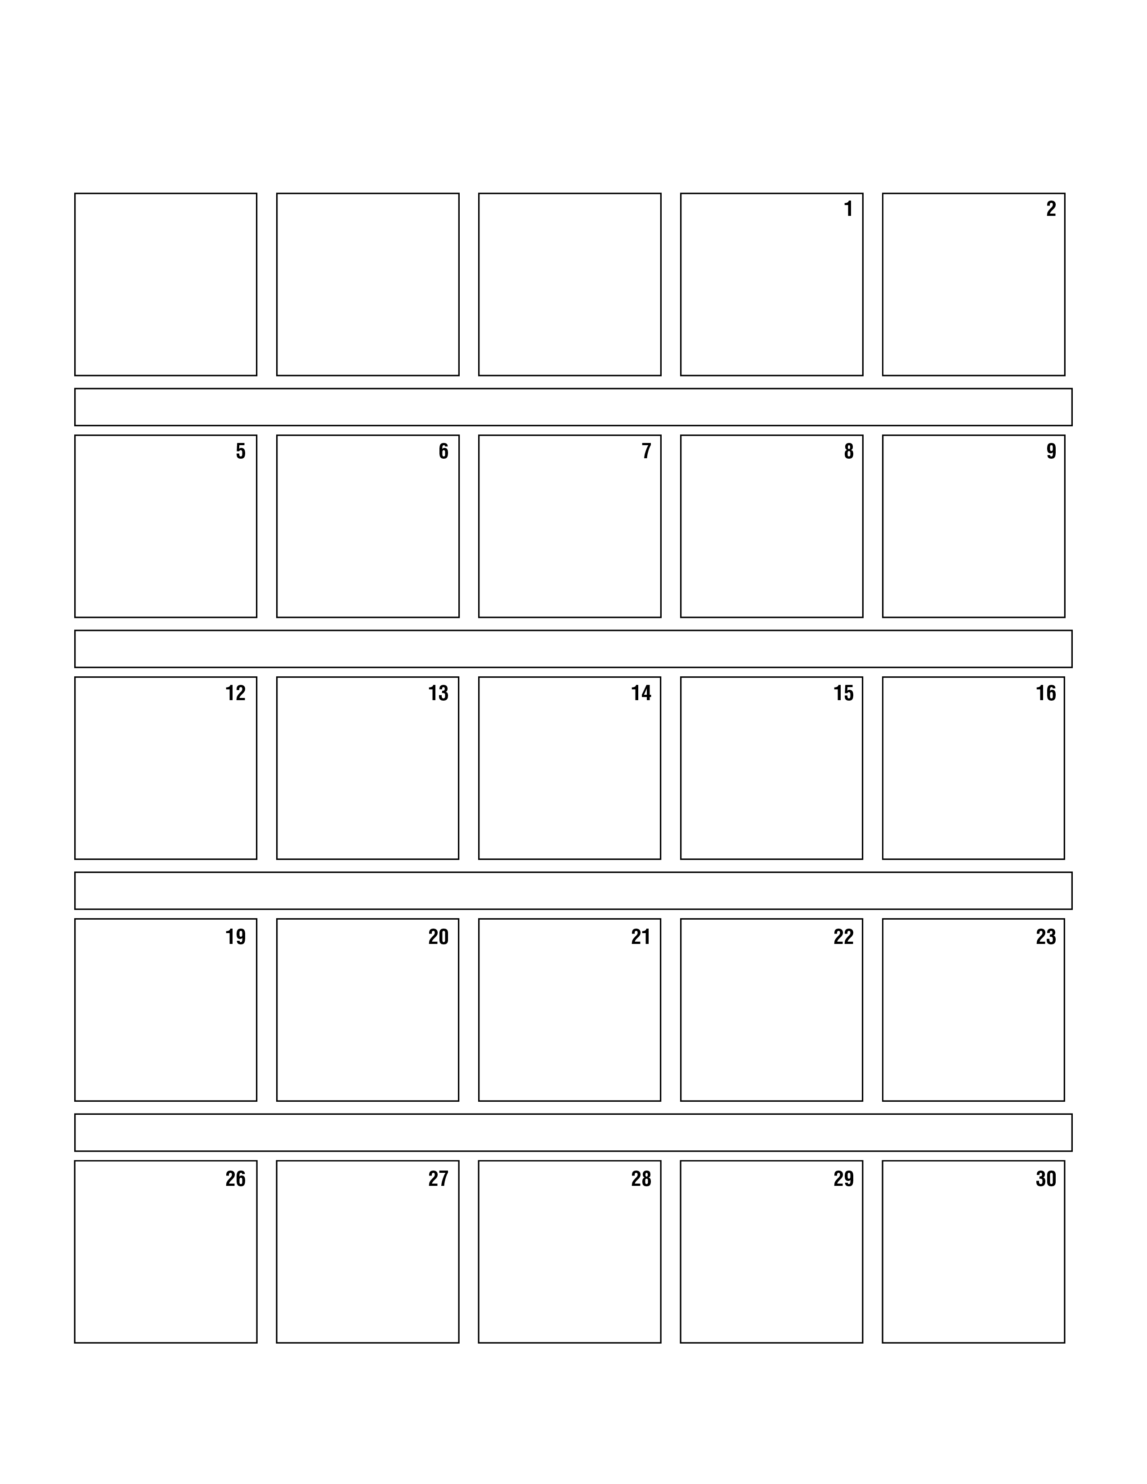
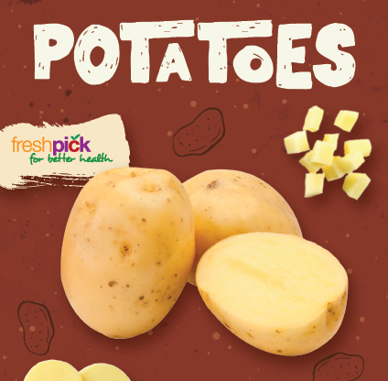
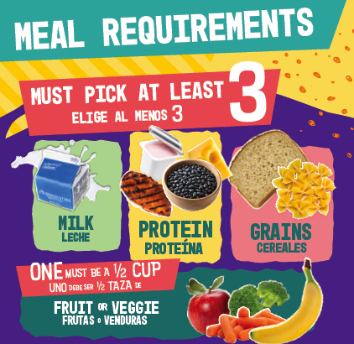
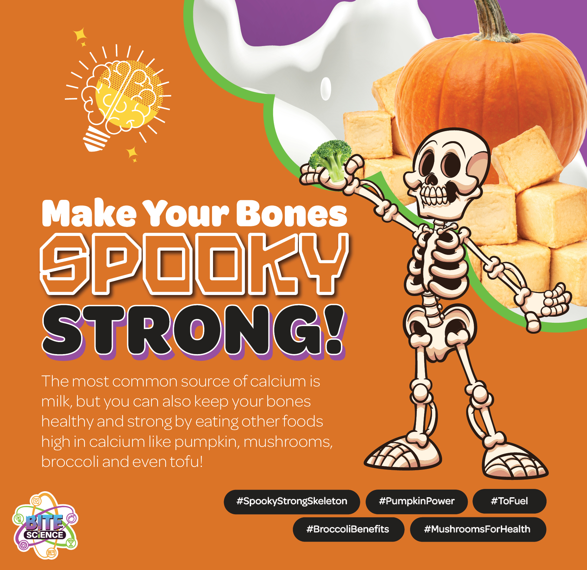
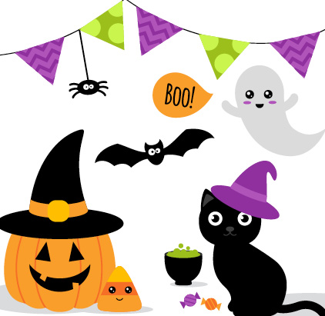

North Olmsted Elementary School

A. Mini Pancakes w/ Yogurt and Cheese Stick
B. Strawberry Fields Parfait
C. Pretzel Chicken Salad w/ Flatbread D. Fun on the Run
E. PBJ Uncrustable w/ Cheese Stick and Pretzel Goldfish Baked Tater Tots Assorted Fruit Milk

A. Big Daddy Cheese Pizza B. Yogurt Bagel Box
C. Crispy Chicken Wrap D. Fun on the Run
E. PBJ Uncrustable w/ Cheese Stick and Pretzel Goldfish Steamed Carrots Assorted Fruit Milk

A. Bosco Cheesy Breadsticks w/ Marinara Dipping Cup B. EZ Breakfast Box
C. Turkey Ham & Cheese Sub D. Fun on the Run
E. PBJ Uncrustable w/ Cheese Stick Pretzel Goldfish Steamed Broccoli Assorted Fruit Milk

A. Cheeseburger on Bun B. EZ Breakfast Box
C. Crispy Chicken Wrap D. Fun on the Run
E. PBJ Uncrustable w/ Cheese Stick and Pretzel Goldfish Vegetarian Baked Beans Assorted Fruit Milk

A. Breaded Chicken Tenders & Dutch Waffle
B. EZ Breakfast Box C. Turkey & Cheese Sub
D. Fun on the Run
E. PBJ Uncrustable w/ Cheese Stick and Pretzel Goldfish Sweet Potato Fries Assorted Fruit Mik

A. Mini Chicken Corn Dogs B. EZ Breakfast Box C. American Sub D. Fun on the Run
E. PBJ Uncrustable w/ Cheese Stick Pretzel Goldfish Baked Tater Tots Assorted Fruit Mik

A. BBQ Chicken Nachos B. EZ Pizza Box
C. Peppi Salad w/ Flatbread D. Fun on the Run
E. PBJ Uncrustable w/ Cheese Stick Pretzel Goldfish Aztec Corn Assorted Fruit Milk

A. Popcorn Chicken w/ Orange Sauce w/ Yakisoba Noodles B. EZ Pizza Box
C. Crispy Chicken Salad w/ Flatbread D. Fun on the Run
E. PBJ Uncrustable w/ Cheese Stick Pretzel Goldfish Steamed Broccoli Assorted Fruit Milk

A. Beef & Cheese Nachos B. EZ Pizza Box
C. Chef Salad w/ Flatbread D. Fun on the Run
E. PBJ Uncrustable w/ Cheese Stick Pretzel Goldfish Seasoned Black Beans Assorted Fruit Milk

A. Bosco Cheesy Breadsticks w/Marinara Dipping Cup B. EZ Pizza Box
C. Taco Salad w/ Tortilla Chips D. Fun on the Run
E. PBJ Uncrustable w/ Cheese Stick Pretzel Goldfish Steamed Green Beans Assorted Fruit Milk

A. French Toast Sticks w/ Yogurt and Cheese Stick
B. EZ Hummus Box
C. Turkey Ham & Cheese Sub D. Fun on the Run
E. PBJ Uncrustable w/ Cheese Stick Pretzel Goldfish Baked Tater Tots Assorted Fruit Milk

A. Mini Maple Pancakes w/ Turkey Sausage
B. EZ Hummus Box C. Crispy Chicken Wrap
D. Fun on the Run
E. PBJ Uncrustable w/ Cheese Stick Pretzel Goldfish Smile Fries Assorted Fruit Milk

A. Breaded Chicken Drumstick w/ Biscuit
B. EZ Hummus Box C. Turkey & Cheese Sub
D. Fun on the Run
E. PBJ Uncrustable w/ Cheese Stick Pretzel Goldfish Mashed Potatoes w/ Gravy Assorted Fruit Milk

A. General Tso Chicken w/ Brown Rice
B. EZ Hummus Box C. American Sub D. Fun on the Run
E. PBJ Uncrustable w/ Cheese Stick Pretzel Goldfish Steamed Broccoli & Carrots Assorted Fruit Milk

A. Penne w/ Beef Meatballs w/ Roll B. Strawberry Fields Parfait C. Peppi Salad w/ Flatbread D. Fun on the Run
E. PBJ Uncrustable w/ Cheese Stick and Pretzel Goldfish
Steamed Green Beans Assorted Fruit Milk

A. Breaded Chicken Patty on Bun B. Strawberry Fields Parfait
C. Crispy Chicken Salad w/ Flatbread D. Fun on the Run
E. PBJ Uncrustable w/ Cheese Stick and Pretzel Goldfish Steamed Carrots Assorted Fruit Milk

A. Chicken Nuggets w/ Roll B. Strawberry Fields Parfait C. Chef Salad w/ Flatbread D. Fun on the Run
E. PBJ Uncrustable w/ Cheese Stick Pretzel Goldfish Steamed Green Beans Assorted Fruit Milk

A. Big Daddy Cheese Pizza B. Strawberry Fields Parfait
C. Taco Salad w/ Tortilla Chips D. Fun on the Run
E. PBJ Uncrustable w/ Cheese Stick Pretzel Goldfish Steamed Corn Assorted Fruit Milk

First Meals are Free!

A. Big Daddy Cheese Pizza B. Yogurt Bagel Box
C. Crispy Chicken Wrap D. Fun on the Run
E. PBJ Uncrustable w/ Cheese Stick and Pretzel Goldfish Steamed Green Beans Assorted Fruit Milk

A. Big Daddy Cheese Pizza B. Yogurt Bagel Box
C. Turkey & Cheese Sub D. Fun on the Run
E. PBJ Uncrustable w/ Cheese Stickand Pretzel Goldfish Steamed Broccoli Assorted Fruit Milk

A. Mummy Dog (dough wrapped beef hot dog)
B. Bagel Yogurt Box C. American Sub D. Fun on the Run
E. PBJ Uncrustable w/ Cheese Stick and Pretzel Goldfish
Baked Brains (Baked Beans) Ghostly Smiles (Apple Slices) Graveyard Dirt (Chocolate Pudding)

