North Olmsted Elementary Schools June 2026

Monday

A. Bosco Cheesy Breadsticks w/ Marinara Dipping Cup

D. Fun on the Run

E. PBJ Uncrustable w/ Cheese Stick and Pretzel Goldfish

Steamed Corn

Assorted Fruits

Milk

Tuesday

A. Beef Hot Dog on Bun

D. Fun on the Run

E. PBJ Uncrustable w/ Cheese Stick and Pretzel Goldfish

Apple Slices

Carnival Cookie

Milk

**********************************************************************************

Summer Meals begin on Monday, June 8. Any child 1 – 18 years may receivea free meal. Meals are served at the following locations:

North Olmsted 6-8 Campus 10:45 – 12:30 Lunch

8:15 – 8:45 Breakfast

Pine School

North Olmsted Rec Ctr
11:00- 12:30 Lunch

11:00 – 12:30 Lunch

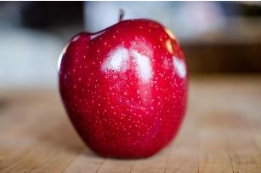

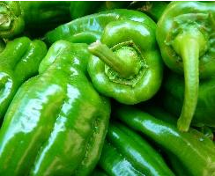
The district will be closed on June 19, July 2, July 3.

